Open IIS manager
Then right mouse click and select properties on the InterfaceService web application.
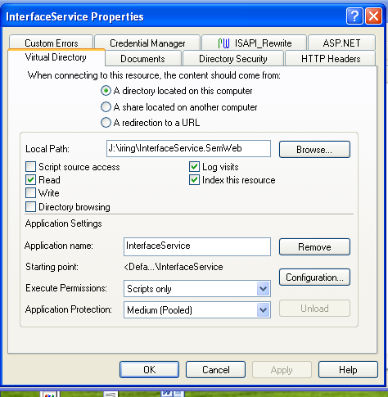

Then click

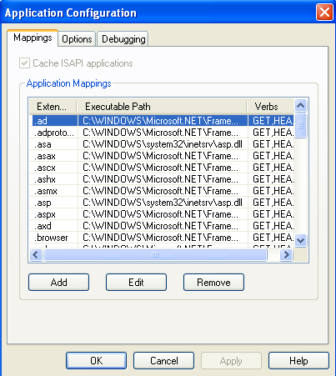

Remove all the mappings and only leave the .aspx mapping so we can use it later
Click ok until the IISManager is closed

DownloadIIS Metabase Exploere 1.1 from http://www.ripcordsoftware.com

Then by using this tool edit the MD_SCRIPT_MAPS

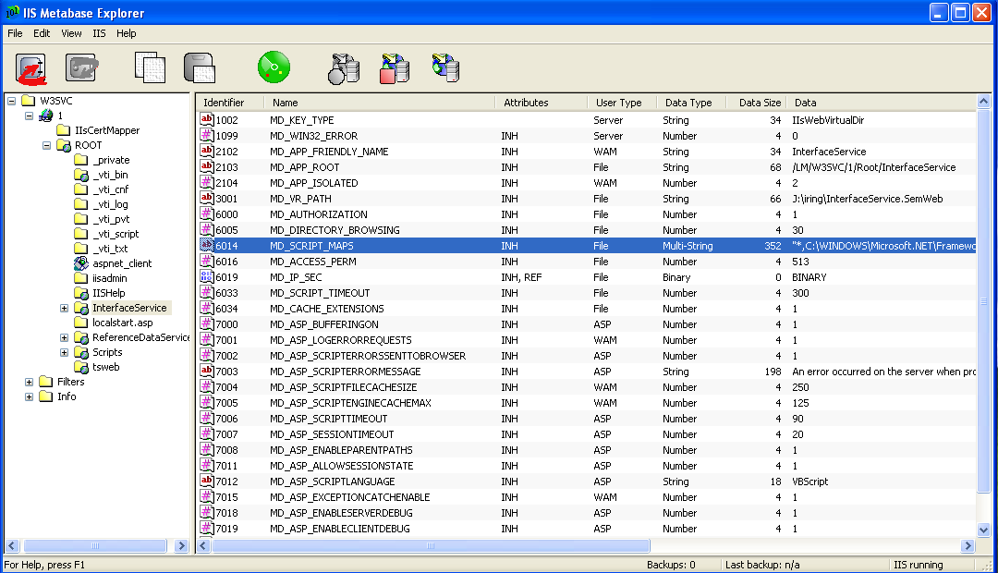

Select the entry we left in the mappings earlier

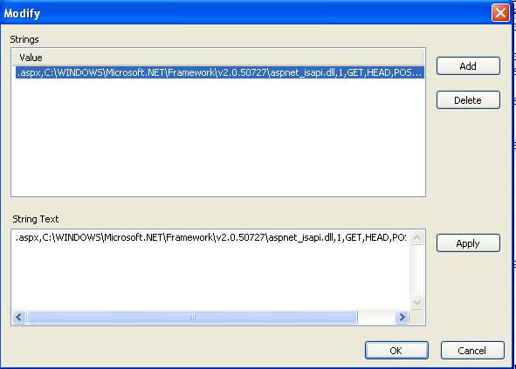

And edit it by changing the .aspx to .* and by clicking the Apply button

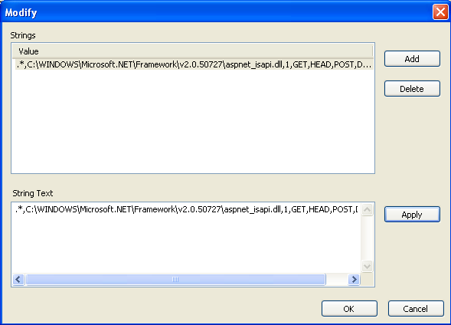

Then select the string text and copy it to the clip board and then click the Add button

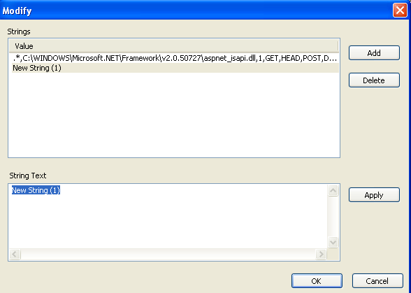

Select and paste the previously copied text over it and changre the .* to * and click the apply button.

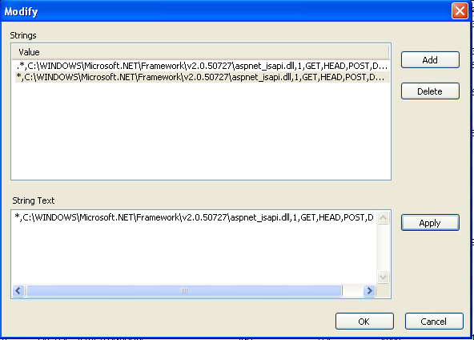

Click ok to accept the changes

In the InterfaceService.Web application add a App_Code folder and the new class MapModule.cs

using System;
using System.Web;

public class MapModule : IHttpModule
{

private HttpApplication context = null;

public void Dispose()
{
context.BeginRequest -= new EventHandler(context_BeginRequest);
}

public void Init(HttpApplication context)
{
this.context = context;
this.context.BeginRequest += new EventHandler(context_BeginRequest);
}

void context_BeginRequest(object sender, EventArgs e)
{
HttpApplication app = (HttpApplication)sender;
app.Response.ContentType = "text/plain";

if (app.Request.Path.EndsWith("sparql"))
app.Server.MapPath("InterfaceService/sparql");
}
}

In the application web.config file make the following change in blue.

<httpModules>
<add name="ScriptModule" type="System.Web.Handlers.ScriptModule, System.Web.Extensions, Version=3.5.0.0, Culture=neutral, PublicKeyToken=31BF3856AD364E35"/>
<add name="MapModule" type="MapModule"/>
</httpModules>

